Full Name: Rakyan Satrya Adhikara

Student ID: 219548135

SIT210 Task 2.1P

Q1: Describe the steps required to modify the code to blink your last name instead?

1. Change ‘ADHIKARA’ in Morse code, which is:
   * A 🡪 .-
   * D 🡪 -..
   * H 🡪 ….
   * I 🡪 ..
   * K 🡪 -.-
   * A 🡪 .-
   * R 🡪 .-.
   * A 🡪 .-
2. Create the code that will display the dots and dashes.
   * To turn the LED on, use the digitalWrite function and set the LED and the status into HIGH
   * To turn the LED off, use the digitalWrite function and set the LED and the status into LOW
3. In addition, set a delay between letter into 500.

Q2: Discuss on the effectiveness of your modifications. Reflect on how you should modify your code to be reusable and modular to adapt quickly to changes in requirements.

The method is not effective since it’s manually written for every dots and dashes. It should be more adaptable by creating function that will scan every input letter and translate it into any format (which on this case, is in Morse code, dots and dashes)

Q3: Create a repository named BlinkName on Github. Upload your code to the repository. Include the link to your repository here.

GitHub link: <https://github.com/radhikara/BlinkName>

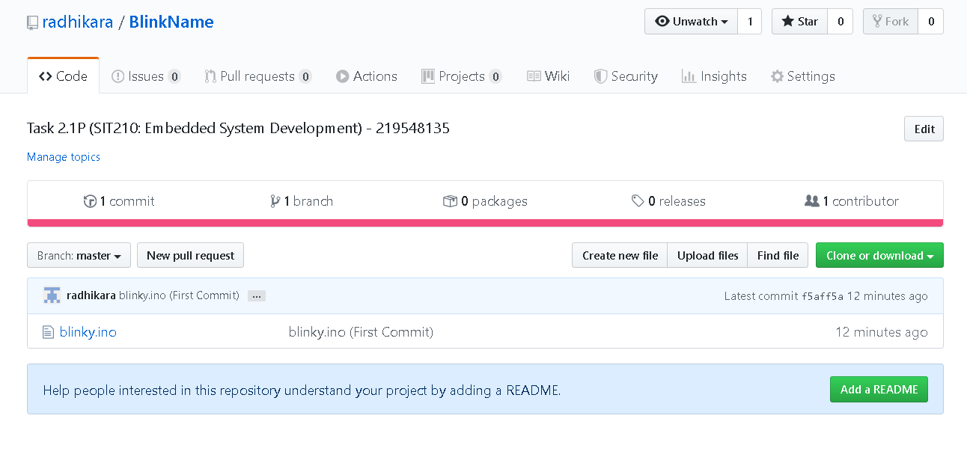

Q4: Take a five second video of your Photon board with the LED blinking your first name and upload it to YouTube. Include the link here.

YouTube Link: <https://www.youtube.com/watch?v=Ic61glE6ToM>

